Advanced SQL Final Project – Mini Data Warehouse (MySQL 8.0)

Mocha Madness – Final Report

Date: September 02, 2025

Group-2

Student:

Dikshali Korat, Harshkumar Damor, Rajkamal Kumaresan, Khaing Mye Naung

Course: Advanced SQL

Professor: Dr. Clement Aladi

# Table of Contents

Insert an automatic Table of Contents in Word: References → Table of Contents → Automatic.

Table of Contents

Table of Contents 2

1. Overview & How to Run 3

2. OLTP Schema (ERD & Constraints) 3

3. OLAP Star Schema & ETL 4

4. Views & “Materialized” View 5

5. Transactions & Concurrency 6

6. Performance & Indexing 7

7. Core Queries (10+) with Business Rationale 8

1. Daily revenue & units (view) 8

2. Top products (30 days) 8

3. MoM revenue by category 8

4. Customer LTV 8

5. New vs Returning (CTE) 8

6. Attachment rate 9

7. Price band performance + HAVING 9

8. Weekday vs weekend 9

9. Pareto products (revenue share) 9

10. Monthly MV usage 10

8. Screenshot Map & Checklist 10

9. Assumptions, Limitations, and Future Work 10

# 

# 1. Overview & How to Run

Goal: Build a small OLTP schema for coffee shop operations and an OLAP star schema for analytics, with views, a simulated materialized view, a transactional stored procedure, and performance indexes.

Environment: MySQL 8.0+, tested in MySQL Workbench.

Run order (from /sql):

1. 01_create_oltp.sql – create and load OLTP schema/data.
2. 02_sample_oltp_data.sql – optional extra seed rows (idempotent).
3. 03_triggers.sql – audit + stock decrement + payment status triggers.
4. 04_olap_schema.sql – create mocha_dw and load dimensions + fact (order_item_id as PK).
5. 05_views.sql – reporting views (daily sales, top products 30d).
6. 06_materialized_view.sql – MV table + refresh procedure (optional event).
7. 07_indexes.sql – add three targeted indexes (capture EXPLAIN before/after).
8. 08_procedures_transactions.sql – transactional sp_place_order.
9. 09_demo_queries.sql – 10+ analytics queries.

# 2. OLTP Schema (ERD & Constraints)

The OLTP schema models customers, orders, order_items, products, employees, payments, and inventory_movements. Constraints enforce data integrity: primary keys for identity, foreign keys for relationships, and ENUMs for small domains.

Key relationships: customers→orders (1:M), orders→order_items (1:M), products→order_items (1:M), orders→payments (1:M), products→inventory_movements (1:M), employees→orders (optional assignment).

Triggers:

* Customer audit (insert/update/delete) writes to customer_audit.
* Order item AFTER INSERT decrements products.stock and logs inventory_movements.
* Payment update sets order status to PAID when payment succeeds.

ERD:

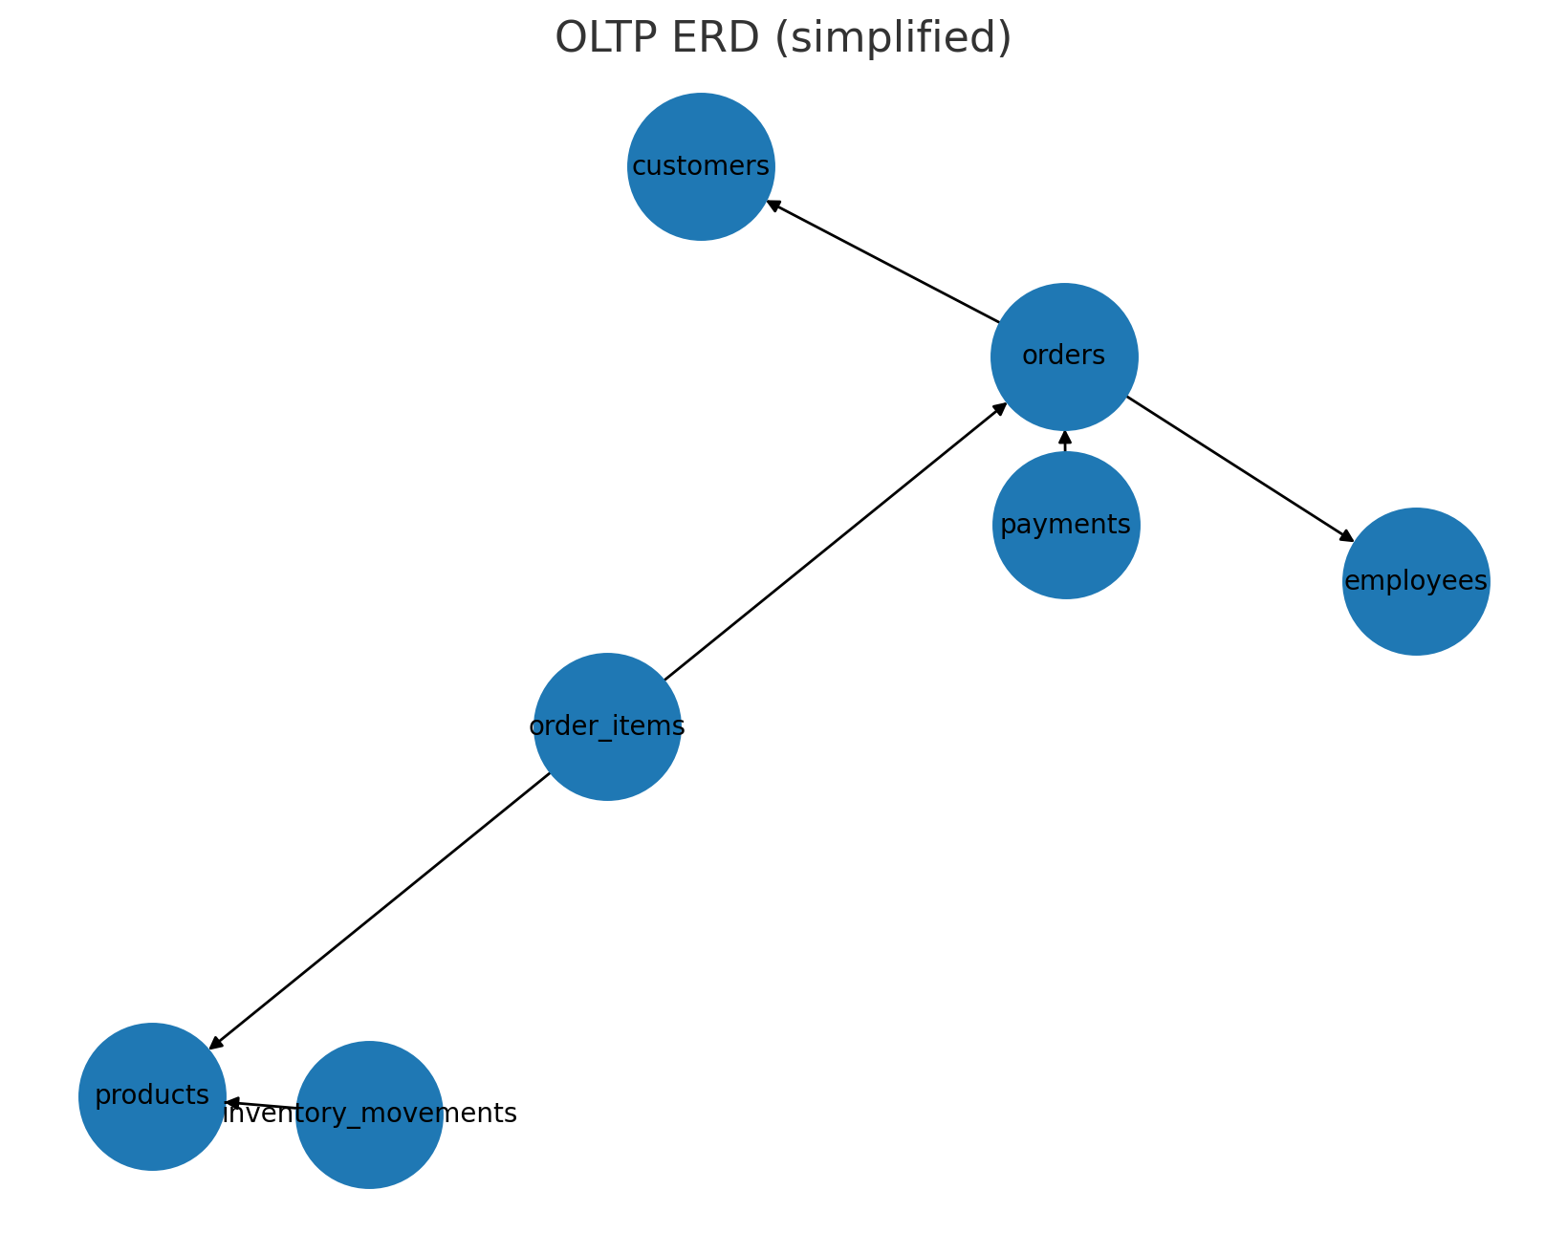

# 3. OLAP Star Schema & ETL

We separate analytics into mocha_dw with a star schema. Grain = one row per order line (matching OLTP order_items). Dimensions: dim_date (calendar), dim_product (name/category/current price), dim_customer (profile).

Why this grain: avoids duplicate-key issues when an order repeats a product on multiple lines; supports drill-down to line level.

ETL summary: build date spine from orders.created_at, upsert products and customers into dims, then load fact_sales with order_item_id as PK.

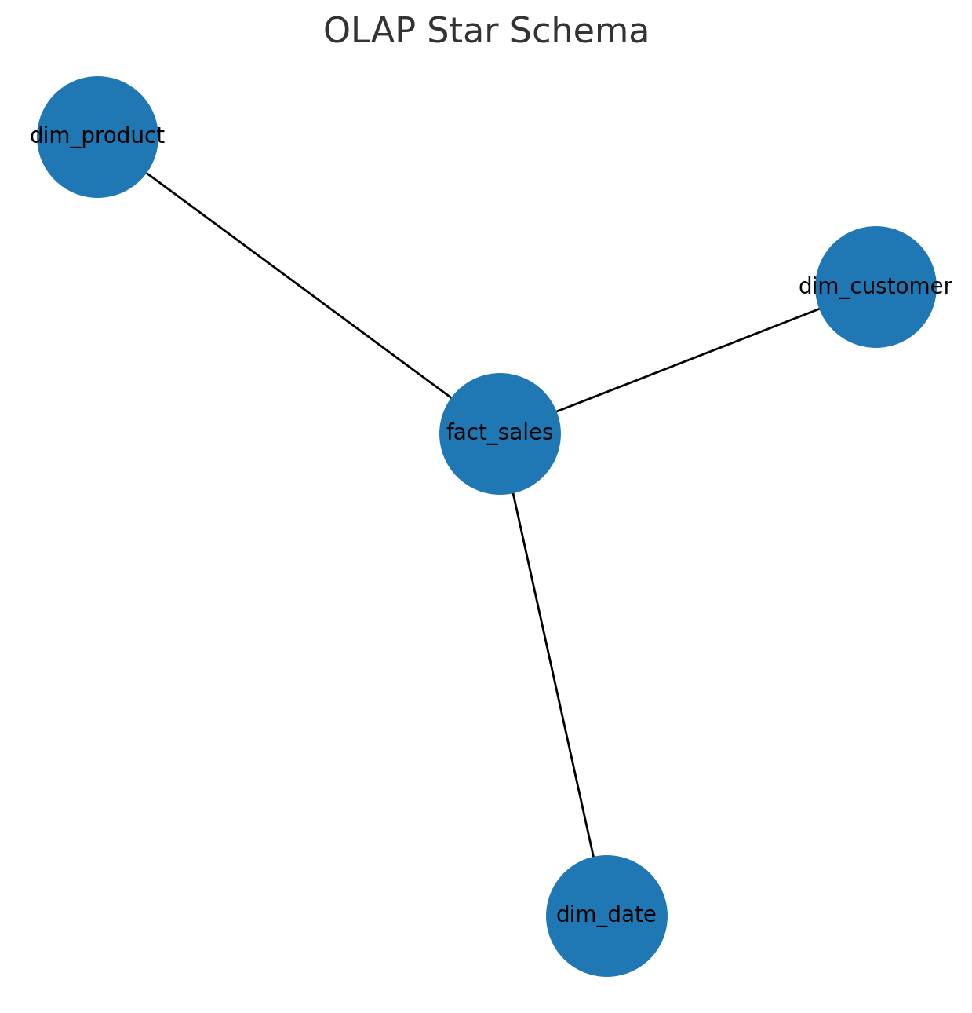

Indexes in OLAP: fact_sales(date_key), fact_sales(product_key), fact_sales(customer_key), and idx_fs_order(order_id).

**Entity Relationship Diagram**

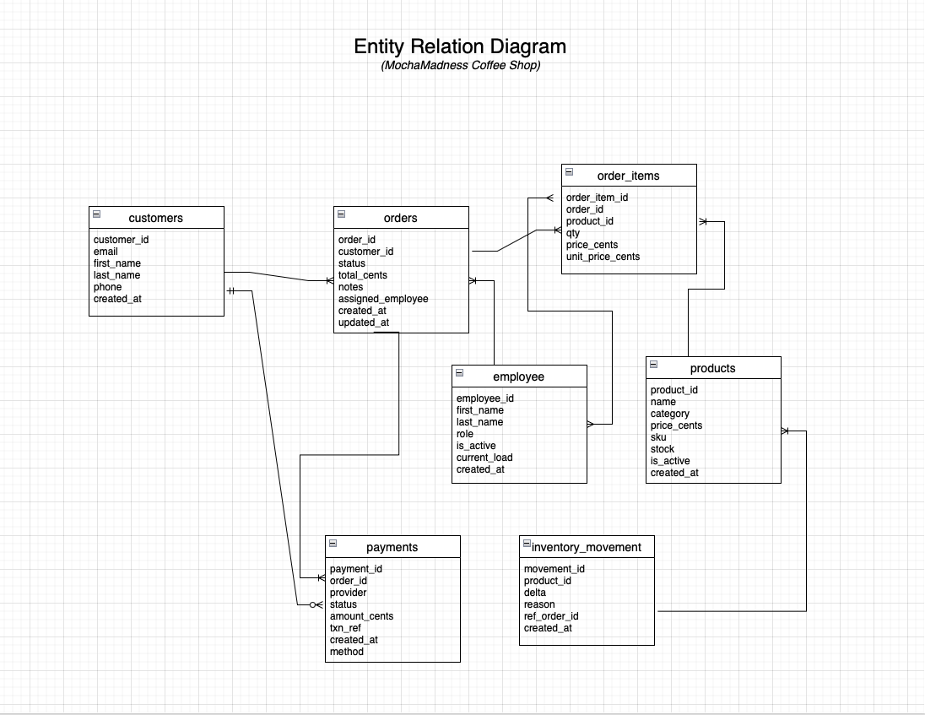

# 4. Views & “Materialized” View

Regular views centralize recurring logic; the MV simulates pre-aggregation for month-end reporting.

Views:

* vw_daily_sales – daily totals (revenue, units) filtered to revenue statuses.
* vw_top_products_30d – top sellers in the last 30 days (revenue, units).

Materialized view (simulated): mv_monthly_product_sales + sp_refresh_mv_monthly_product_sales(). Optional nightly event at 02:00 for automatic refresh.

CREATE VIEW snippets:

USE mocha_dw;  
CREATE OR REPLACE VIEW vw_daily_sales AS  
SELECT d.date_key,  
 SUM(f.line_amount_cents)/100.0 AS sales_usd,  
 SUM(f.qty) AS units  
FROM fact_sales f  
JOIN dim_date d ON d.date_key = f.date_key  
WHERE f.order_status IN ('PAID','READY','COMPLETED')  
GROUP BY d.date_key;

CREATE OR REPLACE VIEW vw_top_products_30d AS  
SELECT p.product_key, p.product_name, p.category,  
 SUM(f.line_amount_cents)/100.0 AS revenue_usd,  
 SUM(f.qty) AS units  
FROM fact_sales f  
JOIN dim_product p ON p.product_key = f.product_key  
WHERE f.order_status IN ('PAID','READY','COMPLETED')  
 AND f.date_key >= (CURRENT_DATE - INTERVAL 30 DAY)  
GROUP BY p.product_key, p.product_name, p.category  
ORDER BY revenue_usd DESC;

MV refresh call:

CALL mocha_dw.sp_refresh_mv_monthly_product_sales();

# 5. Transactions & Concurrency

Stored procedure sp_place_order ensures atomic order placement with stock checks and row locks. We stage the JSON cart into a temp table, snapshot prices, lock only needed product rows using FOR UPDATE, then either ROLLBACK on insufficient stock or COMMIT after inserting lines and updating totals.

Key guarantees: ACID, no overselling (locks), trigger-friendly (no products read in the insert firing the trigger), deterministic totals.

Procedure (excerpt):

DELIMITER $$  
CREATE PROCEDURE sp_place_order(IN p_customer_id INT, IN p_assigned_employee_id INT, IN p_items_json JSON)  
BEGIN  
 DECLARE v_order_id INT; DECLARE v_insufficient INT DEFAULT 0;  
 START TRANSACTION;  
 DROP TEMPORARY TABLE IF EXISTS _req_items;  
 CREATE TEMPORARY TABLE _req_items(product_id INT, qty INT, price_each_cents INT DEFAULT 0, PRIMARY KEY(product_id)) ENGINE=MEMORY;  
 INSERT INTO _req_items(product_id, qty)  
 SELECT jt.product_id, jt.qty FROM JSON_TABLE(p_items_json, '$[*]' COLUMNS(product_id INT PATH '$.product_id', qty INT PATH '$.qty')) jt;  
 UPDATE _req_items r JOIN products p ON p.product_id=r.product_id SET r.price_each_cents=p.price_cents;  
 INSERT INTO orders(customer_id,status,total_cents,assigned_employee_id,notes) VALUES(p_customer_id,'PENDING',0,p_assigned_employee_id,'Placed via sp_place_order');  
 SET v_order_id = LAST_INSERT_ID();  
 SELECT p.product_id FROM products p JOIN _req_items r ON r.product_id=p.product_id FOR UPDATE;  
 SELECT COUNT(*) INTO v_insufficient FROM products p JOIN _req_items r ON r.product_id=p.product_id WHERE p.stock < r.qty;  
 IF v_insufficient > 0 THEN ROLLBACK; DROP TEMPORARY TABLE IF EXISTS _req_items; SELECT 'FAILED_INSUFFICIENT_STOCK' AS result, NULL AS order_id;  
 ELSE  
 INSERT INTO order_items(order_id, product_id, qty, price_cents)  
 SELECT v_order_id, r.product_id, r.qty, (r.price_each_cents * r.qty) FROM _req_items r;  
 UPDATE orders o JOIN (SELECT v_order_id AS order_id, SUM(price_each_cents*qty) AS total_cents FROM _req_items) x ON x.order_id=o.order_id  
 SET o.total_cents=x.total_cents, o.status='PAID';  
 COMMIT; DROP TEMPORARY TABLE IF EXISTS _req_items; SELECT 'SUCCESS' AS result, v_order_id AS order_id;  
 END IF;  
END $$  
DELIMITER ;

Concurrency demo: Session A holds a row lock with SELECT … FOR UPDATE; Session B's order waits until A commits, proving isolation and preventing race conditions.

# 6. Performance & Indexing

Three indexes chosen to match common joins/filters/sorts:

* order_items(order_id, product_id) – speeds joins per order and aggregations per order.
* payments(status, provider) – filters success rate by provider quickly.
* orders(created_at, status) – matches WHERE (recent+paid) + ORDER BY created_at.

EXPLAIN example to capture before/after screenshots:

EXPLAIN  
SELECT o.order_id, o.created_at, SUM(oi.price_cents) AS line_total  
FROM orders o  
JOIN order_items oi ON oi.order_id = o.order_id  
WHERE o.created_at >= CURRENT_DATE - INTERVAL 60 DAY  
 AND o.status IN ('PAID','READY','COMPLETED')  
GROUP BY o.order_id, o.created_at  
ORDER BY o.created_at DESC;

Expected result: reduced rows examined and indexed access on joins/filters after indexes are created.

# 7. Core Queries (10+) with Business Rationale

## 1. Daily revenue & units (view)

Business rationale: Operational trend tracking; plan staffing and purchasing.

SELECT * FROM mocha_dw.vw_daily_sales ORDER BY date_key DESC LIMIT 14;

Insert result screenshot below (from /demo).

## 2. Top products (30 days)

Business rationale: Promotion targeting and stock focus.

SELECT * FROM mocha_dw.vw_top_products_30d LIMIT 10;

Insert result screenshot below (from /demo).

## 3. MoM revenue by category

Business rationale: Seasonality and product-mix shifts.

SELECT d.year, d.month, p.category, ROUND(SUM(f.line_amount_cents)/100.0,2) AS revenue_usd  
FROM fact_sales f JOIN dim_date d ON d.date_key=f.date_key JOIN dim_product p ON p.product_key=f.product_key  
WHERE f.order_status IN ('PAID','READY','COMPLETED')  
GROUP BY d.year, d.month, p.category  
ORDER BY d.year, d.month, revenue_usd DESC;

Insert result screenshot below (from /demo).

## 4. Customer LTV

Business rationale: Identify high-value customers for loyalty.

SELECT c.customer_key, c.email, ROUND(SUM(f.line_amount_cents)/100.0,2) AS lifetime_value_usd  
FROM fact_sales f JOIN dim_customer c ON c.customer_key=f.customer_key  
WHERE f.order_status IN ('PAID','READY','COMPLETED')  
GROUP BY c.customer_key, c.email  
ORDER BY lifetime_value_usd DESC LIMIT 20;

Insert result screenshot below (from /demo).

## 5. New vs Returning (CTE)

Business rationale: Balance acquisition vs retention.

WITH first_order AS (  
 SELECT customer_key, MIN(date_key) AS first_date FROM fact_sales GROUP BY customer_key  
)  
SELECT CASE WHEN f.date_key = fo.first_date THEN 'NEW' ELSE 'RETURNING' END AS cohort,  
 COUNT(DISTINCT f.order_id) AS orders,  
 ROUND(SUM(f.line_amount_cents)/100.0,2) AS revenue_usd  
FROM fact_sales f JOIN first_order fo ON fo.customer_key=f.customer_key  
WHERE f.date_key >= CURRENT_DATE - INTERVAL 60 DAY AND f.order_status IN ('PAID','READY','COMPLETED')  
GROUP BY cohort;

Insert result screenshot below (from /demo).

## 6. Attachment rate

Business rationale: Cross-sell effectiveness.

WITH per_order AS (  
 SELECT order_id, COUNT(DISTINCT product_key) AS distinct_items FROM fact_sales GROUP BY order_id  
)  
SELECT ROUND(100.0 * SUM(distinct_items >= 2)/COUNT(*), 2) AS pct_with_2plus FROM per_order;

Insert result screenshot below (from /demo).

## 7. Price band performance + HAVING

Business rationale: Price sensitivity and mix health.

SELECT CASE WHEN p.current_price_cents < 400 THEN 'Under $4'  
 WHEN p.current_price_cents < 600 THEN '$4–5.99' ELSE '$6+'  
 END AS price_band,  
 SUM(f.qty) AS units,  
 ROUND(SUM(f.line_amount_cents)/100.0,2) AS revenue_usd  
FROM fact_sales f JOIN dim_product p ON p.product_key=f.product_key  
WHERE f.order_status IN ('PAID','READY','COMPLETED')  
GROUP BY price_band HAVING units > 0 ORDER BY revenue_usd DESC;

Insert result screenshot below (from /demo).

## 8. Weekday vs weekend

Business rationale: Staff scheduling and hours.

SELECT CASE WHEN d.day_of_week IN (1,7) THEN 'Weekend' ELSE 'Weekday' END AS day_type,  
 ROUND(SUM(f.line_amount_cents)/100.0,2) AS revenue_usd  
FROM fact_sales f JOIN dim_date d ON d.date_key=f.date_key  
WHERE f.order_status IN ('PAID','READY','COMPLETED')  
GROUP BY day_type;

Insert result screenshot below (from /demo).

## 9. Pareto products (revenue share)

Business rationale: Focus attention on top drivers.

WITH per_product AS (  
 SELECT p.product_key, p.product_name, SUM(f.line_amount_cents) AS rev  
 FROM fact_sales f JOIN dim_product p ON p.product_key=f.product_key  
 WHERE f.order_status IN ('PAID','READY','COMPLETED')  
 GROUP BY p.product_key, p.product_name  
), tot AS (SELECT SUM(rev) AS total_rev FROM per_product)  
SELECT pp.product_key, pp.product_name, ROUND(pp.rev/t.total_rev*100.0,2) AS pct_of_total  
FROM per_product pp CROSS JOIN tot t  
ORDER BY pct_of_total DESC LIMIT 10;

Insert result screenshot below (from /demo).

## 10. Monthly MV usage

Business rationale: Fast month-end reporting leveraging pre-aggregation.

CALL mocha_dw.sp_refresh_mv_monthly_product_sales();  
SELECT * FROM mocha_dw.mv_monthly_product_sales ORDER BY year DESC, month DESC, revenue_usd DESC LIMIT 20;

Insert result screenshot below (from /demo).

# 8. Screenshot Map & Checklist

Include the following in /demo and paste into this document:

* Schema pane (both schemas).
* SHOW CREATE TABLE orders, order_items, products, payments (PKs/FKs/ENUMs).
* Row counts across major tables.
* Views: vw_daily_sales (grid), vw_top_products_30d (grid).
* MV: CALL refresh (Action Output), SELECT from mv table (grid).
* Procedure: SHOW CREATE PROCEDURE sp_place_order.
* Transactions: before stock → SUCCESS → after (stock/movement/order).
* Rollback: FAILED_INSUFFICIENT_STOCK result, no changes.
* Concurrency: Tab A lock, Tab B waiting, Tab B success after commit.
* EXPLAIN before and after creating indexes.

# 9. Assumptions, Limitations, and Future Work

Assumptions: MySQL 8.0+ with JSON_TABLE; event scheduler may be OFF on lab machines; payment success is simulated.

Limitations: No returns/refunds fact; product pricing treated as SCD1 (overwrite).

Future work: add SCD2 for price history, returns/refunds handling, dim_employee for staffing analysis, and BI dashboard layer.

Annexes

# Screenshot Map & Checklist

* Schema pane (both schemas).

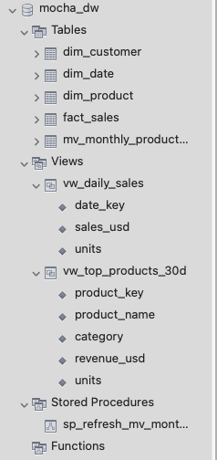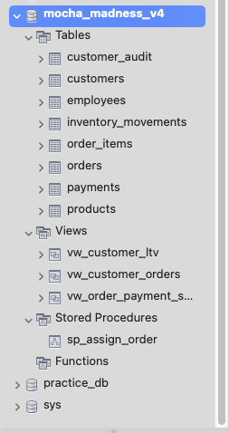

* SHOW CREATE TABLE orders, order_items, products, payments (PKs/FKs/ENUMs).

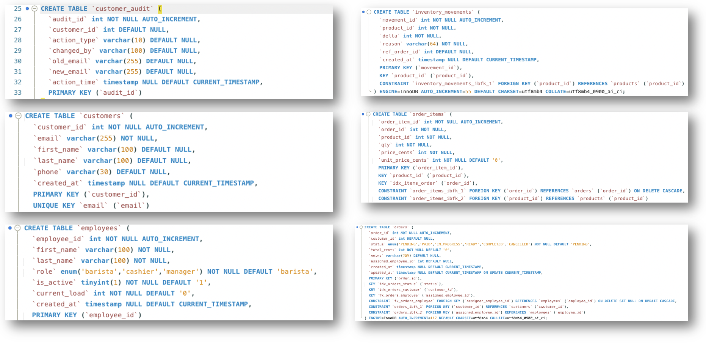

* Row counts across major tables.
* Views: vw_daily_sales (grid), vw_top_products_30d (grid).

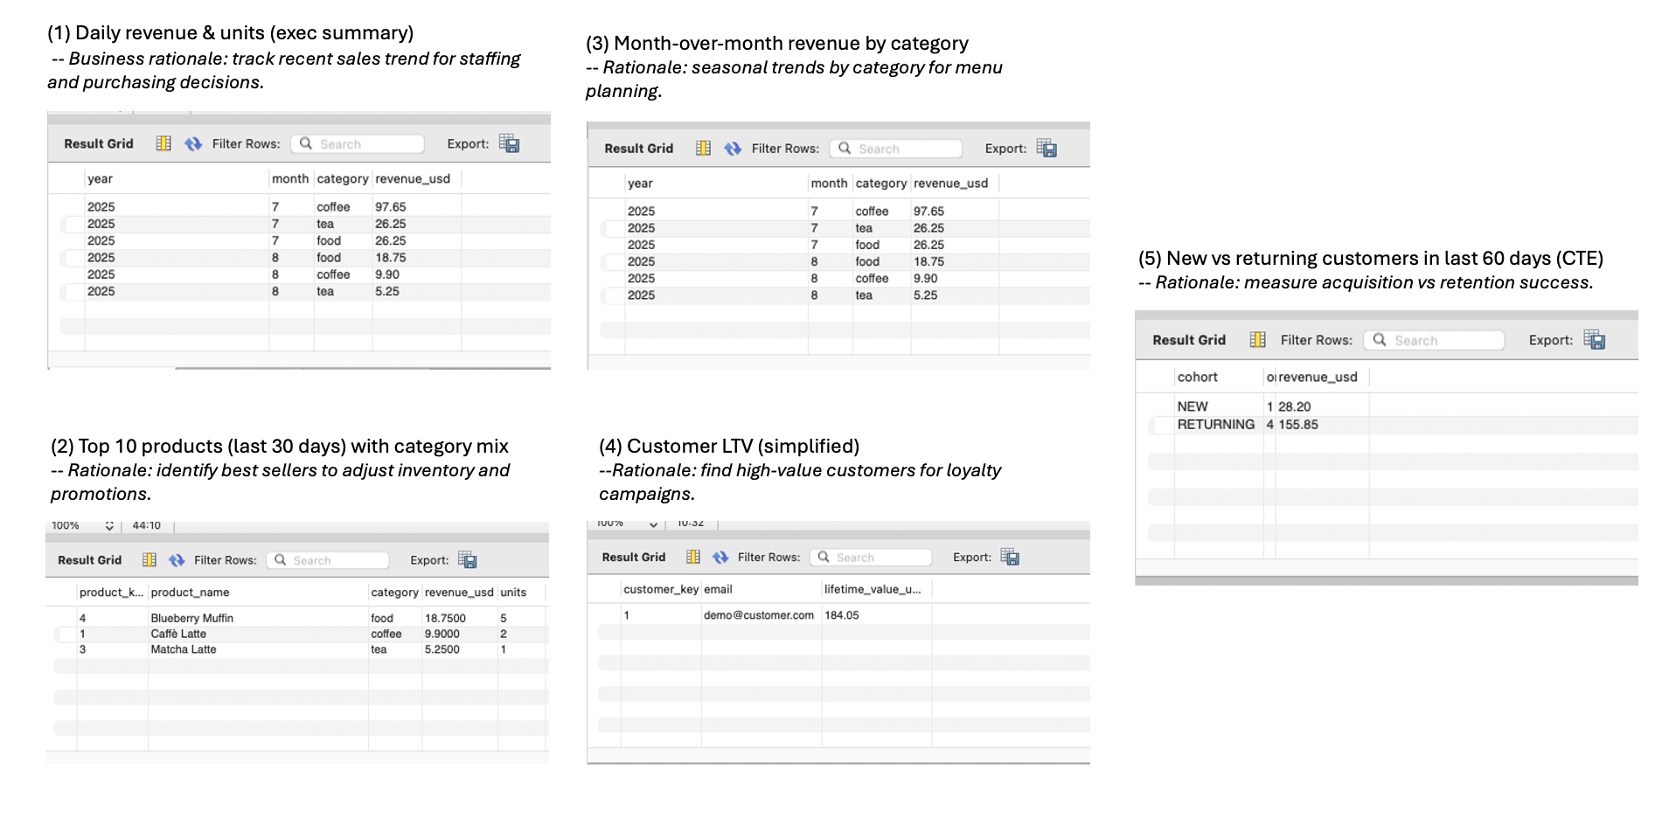

* MV: CALL refresh (Action Output), SELECT from mv table (grid).
* Procedure: SHOW CREATE PROCEDURE sp_place_order.

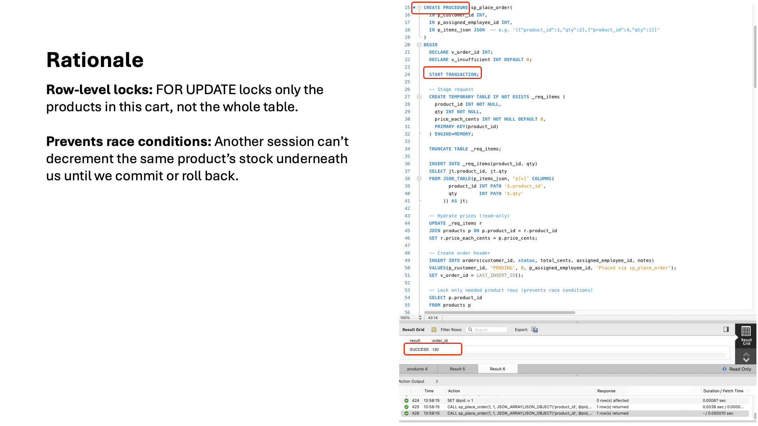

* Transactions: before stock → SUCCESS → after (stock/movement/order).
* Rollback: FAILED_INSUFFICIENT_STOCK result, no changes.
* Concurrency: Tab A lock, Tab B waiting, Tab B success after commit.

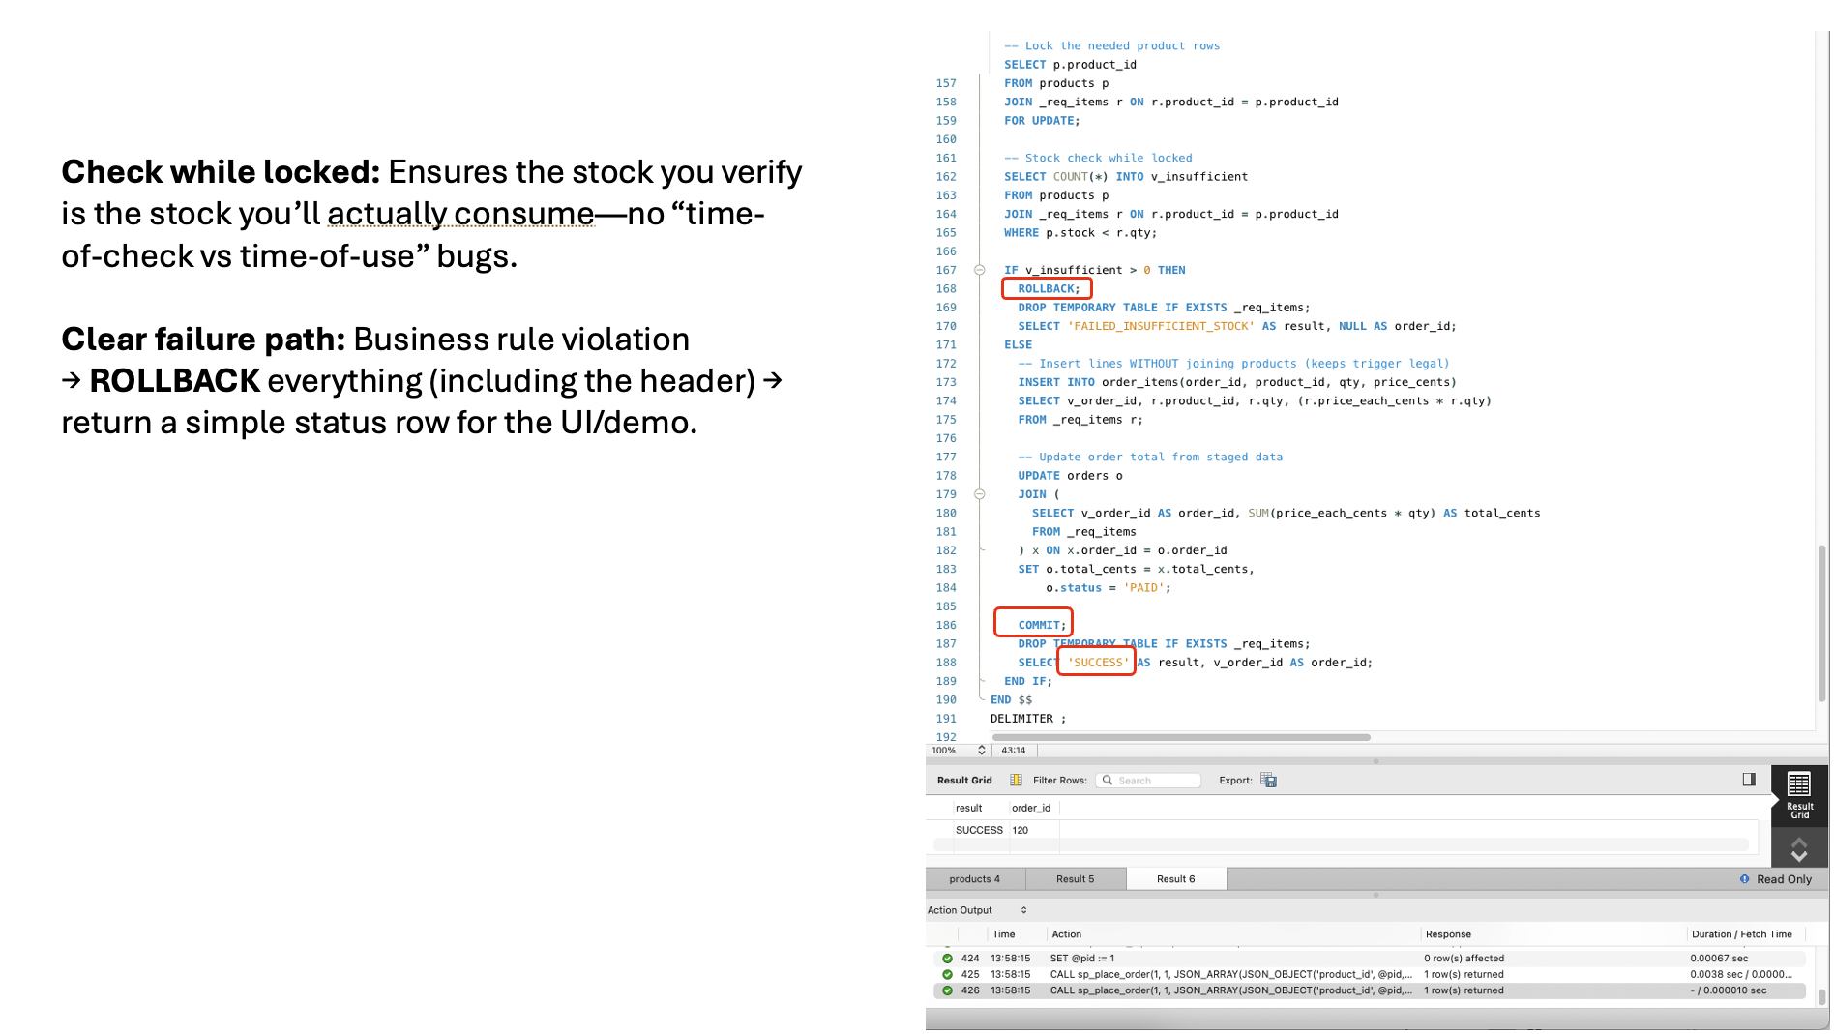

* EXPLAIN before and after creating indexes.

